By : Ong Swee Seng and Leong Weng Yan Ivan

Group : Seng Seng

**Proposal/Report : Assignment 1 (Finite State Machine)**

________________________________________________________________________

Design 2 FSMs ( minimum 3 states) for game scene by circling states, conditions in written descriptive statements in space below. Draw the State Transition Diagram.

**FSM # 1** States

Waitress Artificial Intelligence

* While there is free tables available and customer in the queue, **usher** customer to seat
* When there is no free tables **return** to idle
* While there are customers ready to order, **take** order from customer
* After taking order from customer, **place** order with chief
* If there are no customers ready to order anymore, **return** to idle
* If there are food to pick up, waitress will **take** food from chief
* Once there are no more food to pick-up, **delivery** food to customer
* If there are no more food to delivery, **return** to idle
* While there are dirty tables, waitress would proceed on and **clean** tables
* If there are no more dirty tables, **return** to idle

Conditions

* While there is **free tables available** and **customer in the queue**, usher customer to seat
* When there is **no free tables** return to idle
* While there are **customers ready to order**, take order from customer
* **After taking order from customer**, place order with chief
* If there are **no customers ready to order** anymore, return to idle
* If there are **food to pick up**, waitress will take food from chief
* Once there are **no more food to pick-up**, delivery food to customer
* If there are **no more food to delivery**, return to idle
* While there are **dirty tables**, waitress would proceed on and clean tables
* If there are **no more dirty tables**, return to idle

State Transition Diagram

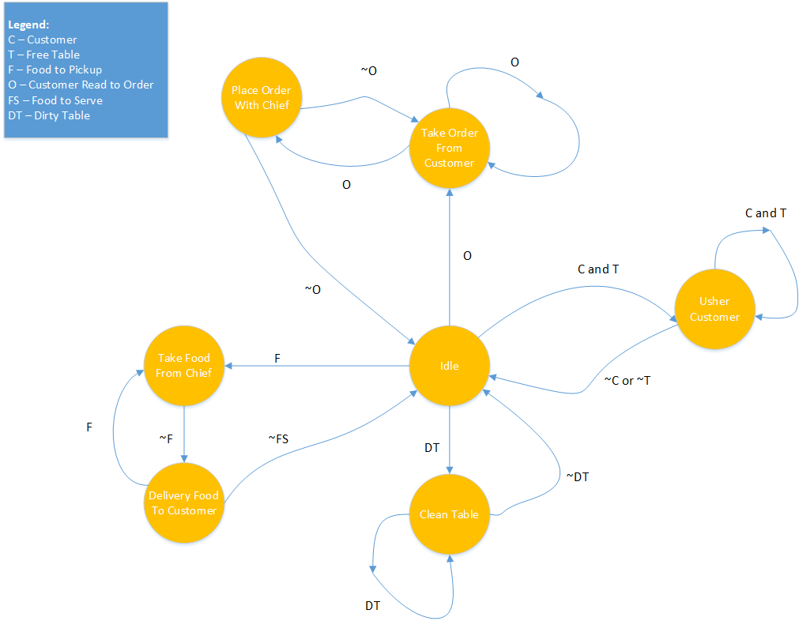

**FSM # 2**

Customer Artificial Intelligence

States

* After walking into the store, **que up** and wait for the waitress
* When there are free tables and waitress comes to usher, follow waitress to table and **sit down**
* After deciding what to eat, get **ready to order**
* If waiter takes too long to come, **leave** the store
* Else if waiter comes in time, tell waiter the **order**
* After ordering, **wait for food** to cook
* When food arrives, start to **eat**
* When finish eating, **leave** the store

Conditions

* After **walking into the store**, que up and wait for the waitress
* When there are **free tables** and **waitress comes** to usher, follow waitress to table and sit down
* After **deciding what to eat**, get ready to order
* If waiter **takes too long** to come, leave the store
* Else if **waiter comes in time**, tell waiter the order
* **After ordering**, wait for food to cook
* When **food arrives**, start to eat
* When **finish eating**, leave the store

State Transition Diagram

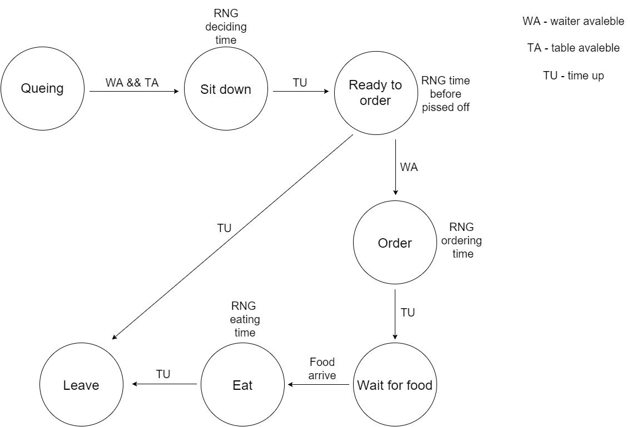

**FSM # 3**

Chief Artificial Intelligence

States

* If there is order available, **cook**
* When finish cooking, go to **place food**
* After food is placed, go back to **Idle**

Conditions

* If there is **order available**, cook
* When **finish** **cooking**, go to place food
* After **food is placed**, go back to Idle

State Transition Diagram

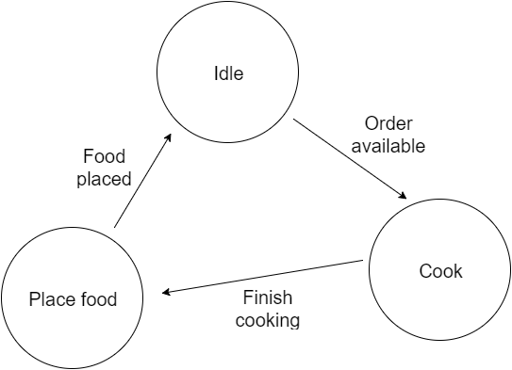

Additional Information

Good to have

* Pathfinding for AI
* Probability for waitress to slip and fall